**TestNG**

## **What is the significance of testng.xml?**

Advantages of using testng.xml file are:

* It allows execution of multiple test cases from multiple classes.
* It allows parallel execution.
* It allows execution of test cases in groups, where a single test can belong to multiple groups.

## **What is parameterization in TestNG? How to pass parameters using testng.xml?**

Parameterization is the technique of defining values in testng.xml file and sending them as parameters to the test class. This technique is especially useful when we need to pass multiple login credentials of various test environments. Look at the code below, in which “myName” is annotated as a parameter.

**public** **class** ParameterizedTest1 {

@Test

@Parameters("myName")

**public** **void** parameterTest(String myName) {

System.***out***.println("Parameterized value is : " + myName);

}

}

To pass parameters using testng.xml file, we need to use ‘parameters’ tag. Look at the below code for example:

|  |  |
| --- | --- |
|  | <?xml version="1.0" encoding="UTF-8"?>  <!DOCTYPE suite SYSTEM "http://testng.org/testng-1.0.dtd" >  <suite name=”CustomSuite">  <test name=”CustomTest”>  <parameter name="myName" value=”John"/>  <classes>  <class name="ParameterizedTest1" />  </classes>  </test>  </suite> |

## **Explain DataProviders in TestNG using an example. Can I call a single data provider method for multiple functions and classes?**

DataProvider is a TestNG feature, which enables us to write DataDriven tests. When we say, it supports Data Driven testing, then it becomes obvious that the same test method can run multiple times with different datasets. Data Provider is in fact another way of passing parameters to the test method.

**@DataProvider** marks a method as supplying data for a test method. The annotated method must return an Object[] where each Object[] can be assigned to parameter list of the test method.

To use the DataProvider feature in your tests, you have to declare a method annotated by **@DataProvider** and then use the said method in the test method using the ‘dataProvider‘ attribute in the Test annotation.

As far as the second part of the question is concerned, Yes, the same DataProvider can be used in multiple functions and classes by declaring DataProvider in separate class and then reusing it in multiple classes.

## **How to skip a method or a code block in TestNG?**

If you want to skip a particular test method, then you can set the ‘enabled’ parameter in test annotation to false. @Test(enabled = false)

By default, the value of ‘enabled’ parameter will be true. Hence it is not necessary to define the annotation as true while defining it.

## **What is soft assertion in Selenium? How can you mark a test case as failed by using soft assertion?**

Soft Assertions are customized error handlers provided by TestNG. Soft Assertions do not throw exceptions when assertion fails, and they simply continue to the next test step. They are commonly used when we want to perform multiple assertions.

To mark a test as failed with soft assertions, call **assertAll()** method at the end of the test.

**What is priority feature in TestNG? In addition, how we can use this?**

Ans:- If you want the @Test methods to be executed in your order, then you need to use the ‘priority‘ .

Like First we need to execute a test case "Registration" before login. In order to achive, we use need to add annotation as @Test(priority=??).

Sequence of execution is in ascending order of value. “0”is having highest priority so it will be executed first. There is no need for your values to be consecutive

Example:- @Test (priority=0)

Note : Priority can be negative and the execution will be from Negative to Positive.

**How to execute multiple test cases in Selenium?**

Ans:- using TestNG.xml

**How to execute parallel test cases in Selenium?**

Ans:- There are two ways

1> using DataProvideranotation :- @DataProvider(parallel=true)

2> using testng.xml :- <suite name="My suite" parallel="methods" >

**How to execute only failed test cases in Selenium?**

Ans:-

Every time tests fail in a suite, TestNG creates a file called testng-failed.xml in the output directory.

This XML file contains the necessary information to rerun only these methods that failed, utlizing this we can easily rerun the failed tests without having to run the entire test suite.

## **Explain what is Group Test in TestNG?**

In TestNG, methods can be categorized into groups. When a particular group is being executed, all the methods in that group will be executed.  We can execute a group by parameterizing it’s name in group attribute of**@Test** annotation. Example: @Test(groups={“xxx”})

|  |  |
| --- | --- |
|  | @Test(groups={“Car”})  public void drive(){  system.out.println(“Driving the vehicle”);  }  @Test(groups={“Car”})  public void changeGear() {  system.out.println("Change Gears”);  }  @Test(groups={“Car”})  public void accelerate(){  system.out.println(“Accelerating”);  } |

## **How does TestNG allow you to state dependencies? Explain it with an example.**

**Dependency**is a feature in TestNG that allows a test method to depend on a single or a group of test methods. Method dependency only works if the “depend-on-method” is part of the same class or any of the inherited base classes (i.e. while extending a class). Syntax:  
**@Test(dependsOnMethods = { “initEnvironmentTest” })**

|  |  |
| --- | --- |
|  | @Test(groups={“Car”})  public void drive(){  system.out.println(“Driving the vehicle”);  }    @Test(dependsOnMethods={“drive”},groups={cars})  public void changeGear() {  system.out.println("Change Gears”);  }  @Test(dependsOnMethods={“changeGear”},groups={“Car”})  public void accelerate(){  system.out.println(“Accelerating”);  } |

## **Explain what does @Test(invocationCount=?) and @Test(threadPoolSize=?) indicate.**

**@Test(invocationCount=?)** is a parameter that indicates the number of times this method should be invoked.  
**@Test(threadPoolSize=?)** is used for executing suites in parallel. Each suite can be run in a separate thread.

To specify how many times @Test method should be invoked from different threads, you can use the attribute**threadPoolSize** along with **invocationCount**. Example:

|  |  |
| --- | --- |
|  | @Test(threadPoolSize = 3, invocationCount = 10)  public void testServer() { |

}

**Difference between Java Program and TestNg Script?**

Ans- When we execute Java program and TestNG script then functionality wise nothing will change because our script is performing the same functionality but using TestNG you will get some additional functionality.

Some benefit of TestNG Script:

1- For even single test case you will get 3 reports. These reports generated by TestNG

2-You can check execution time i.e. How much time test case has taken

3-Parallel execution

**How we can write TestNG Script?**

Ans- To execute TestNG script we don’t have to write the separate class. We can use simple java class but here we will not write public static void main(String []args) because we are not going to execute this from JVM.

TestNG works with Annotations and annotation can be represented by @ symbol

@Test- is this the main annotation from where TestRunner will start execution.

In other words, you can say @Test in entry point

**Can you tell about this , where the Test NG Program will run if not in JVM**

“we will not write public static void main(String []args) because we are not going to execute this from JVM.”

Annotations of TestNG are itself a class which contains the definition of main() method due to which annotations drives compilation forward.

**how to run only skipped test cases in selenium web driver?**

rerun test cases also can be run by testng-failed.xml file.

**I want to run some method in sequential order and some in parallel in testng.how would u configure the testng.xml?**

In this case you can create 2 xml file. One will run in parallel and one in sequence.

you can with single xml as well but for this-You can convert all script in testng.xml file and you can trigger direct from eclipse or ant or pom.

**How to run failed TC?**

test output-suitname-TestNG will generate testng-failed.xml- you can run this one only

OR

Consider you have 10 test cases in Selenium and you have created a testng.xml to execute all test cases.

Now you create another 20 test cases which belong to the same project, but they belong to different module so again we created testng1.xml for the same.

If the same process goes on, then at last you must be having couple of xml files which will be having all the testcases.

Now the real problem is if you want to execute all xml in one shot then you cannot do because Eclipse will allow to execute only one xml.

In this case we can take help of a TestNG class which allow us to execute multiple xml in one shot.

@Test

**public** **void** test() {

TestNG runner = **new** TestNG();

List<String> list = **new** ArrayList<String>();

list.add("testng.xml");

runner.setTestSuites(list);

runner.run();

}

**Note:** I got a case. For suppose I have 100 test cases, in that 100 I want to execute only 20 test cases. Is there any way to skip the 80 test cases, rather using enable=false, for all the 80 test cases. Grouping of test case will work for you.

Create group of test cases then decide which group to run which do not has to run via XML file(testng.xml).

Best and easy way to Group test cases in selenium

For Example- If we have 200 test case out of these some are end to end test cases, some are the functional test case and some are regression or smoke test cases so if you don’t categorize these test cases these all test case will come under one common category.

@Test(groups={"Smoke"})

@Test(groups={"group1","group2"})

After grouping in Selenium we can specify the include and exclude in testng.xml.

<include> – It tells testng.xml that which group we need to execute.

<exclude>- It tells testng.xml which group we have to Skip

public class TestGroupDemo {

@Test(groups={"Smoke"})

public void login(){

System.out.println("Login done");

System.out.println("Smoke Scenario passed");

}

@Test(groups={"Regression"})

public void register(){

System.out.println("Registration done");

}

}

<suite name="Suite" parallel="none">

<test name="Test">

<groups>

<run>

<include name="Smoke" />

<exclude name="Regression"/>

</run>

</groups>

<classes>

<class name="testngDemo.TestGroupDemo"/>

</classes>

</test> <!-- Test -->

</suite> <!-- Suite -->

**Can we group the different methods from different classes and run them together.**

Let suppose: We have 3 classes and in each class we have 3 methods. So can we group as: 2 methods from class 1, 2 method from class 2 and 1 methods from class 3?

Ans-Yes

**Benefits of Running parallel execution in selenium**

It saves execution effort.

We can cover a number of tests.

We can perform cross-browser testing as well which will make the application more stable.

If you are running scripts parallelly then it will help you to increase ROI (return of Investment)

We need to understand some topics before proceeding further.

TestNG internally handles threading concepts which will allow us to run the test in multiple threads.

Each thread will be assigned to individual test so if you have fewer threads than Test will get same thread if free.

You need to separate machine for parallel execution or machine with good resources which can handle multiple browsers at one time.

Thread count

You need to also consider thread-count in TestNG which will create threads based on our requirement.

I have some use case which will make your concept clearer.

Scenario 1- If you have three test cases and thread count is only 1 then the single thread will execute all test which is of no use.

Scenario 2- If you have three test cases and thread count is two then you will notice parallel execution because one thread will execute one test and one thread will execute two.

Scenario 3- If you have three test cases and thread count is three then each thread will execute an individual test and you will notice execution time will be less.

Listeners-allow to customize your Logs and report of TestNG

Listen to certain event and behave accordingly

ItestListner-class level, suite level

there are 5 ways of logging now i have learned so far from the site.

Can you please correct me if i am wrong somewhere or anything to be added. Its like a summary

1) Reporter.log

A simple print statement

2) testNG

The most easiest way since you just have to extend the interface and you get advance logging

3) WebDriverEventliStener

This a little complex since you have yo create 2 classes . One extending other class and use different object than driver but logging details are very good liked

you click on which link, you navigated where

4) Log4j

external library, it has 4 different things under it and has its own syntax and classes

5) Extent report

**POM design - Architecture & Pattern & Framework**

Let us talk about a simple situation where I ask a few team members to write different tests on same application. The starting point would be a set of requirements that I want everybody to adhere:

* Automate some piece of functionality.
* Implement Logging
* Implement Reporting

All the team members will go back to their seats, will read the requirements assigned to them and will write the tests in a way that they are most comfortable with.

**What's the problem here?**

* All the tests will be written in different ways. That will cause a problem in running them together.
* All the tests will have custom ways of logging, that will bring in problem in collecting logs at the end of test run.
* All tests will have different ways to fetch test data, some will be hardcoded, and some will pick from different XML or excel sheets.

**What's the problem here?**

* As the test are on same application, there is a high probability that all test will pass through common areas of application. It will cause duplication of code everywhere.
* All test will report pass or fail in their own way. Causing report collection a nightmare.
* Now all tests are different, so running them would also be different. A custom runner for every test is just an insane thought.

**Why we need Framework**

* The initial requirement of having a standard way of writing tests is what will evolve into a framework.
* Every company or teams can have different frameworks but the whole idea will be to have a common set of rules.

What is a framework

- A framework is a set of assumptions, concepts and practices that needs to be followed.

Components of frameworks

The first problem that we came across we found the need of having a test writing standard, where test will be written in a specific format that will enable us to have a uniformity around all the tests

Req 1) Test case standardization.

The second problem that we came across to have a common way of logging tests. This will enable us have a common way of collecting logs

Req 2) Logging standardization.

We know that our tests need test data and our framework will need data to find out environment and configuration details. This came out as the third problem.

Reg 3) Test data and configuration utility.

Fourth problem that we saw was in terms of having function/procedures that help us perform functions in the overlapping areas of functionality without knowing the details of that functionality.

Eg. Lets say you want to test the payment gateway but to reach there you have to go through by login. So login can be a function/procedure or a module to abstract out logging complexity

Reg 4) Helper/Utility library

As all the tests were different we were not able to run them in a consistent way. This gives a need to have a consistent test running calls defined by

Reg 5) Test execution engine.

Reporting was big concern as all the test for not conforming to a fixed reporting pattern.

Reg 6) Reporting utility.

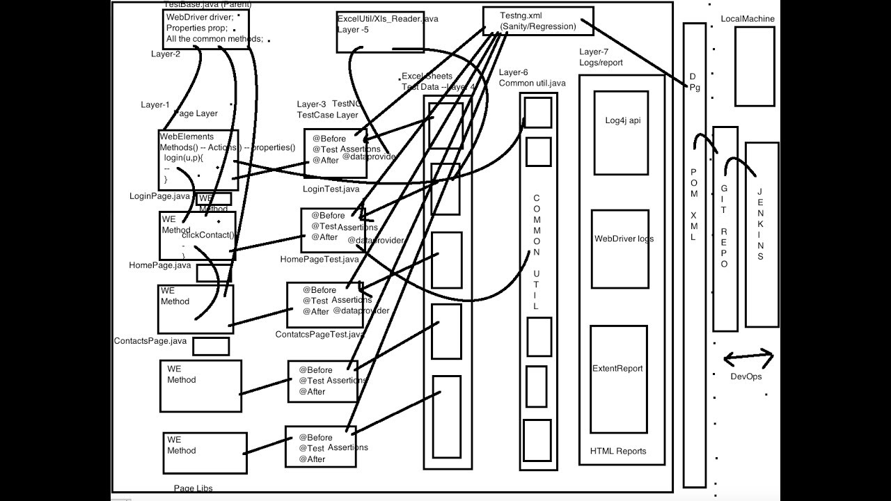

**Cucumber**

**Explain** **Cucumber shortly.**

Ans: Cucumber is a Framework that is based on Behaviour Driven Development (BDD) methodology.

The main aim of Behaviour Driven Development framework is to make various project roles such as Business Analysts, Quality Assurance, Developers etc., understand the application without diving deep into the technical aspects.

**Cucumber Framework Architecture:**

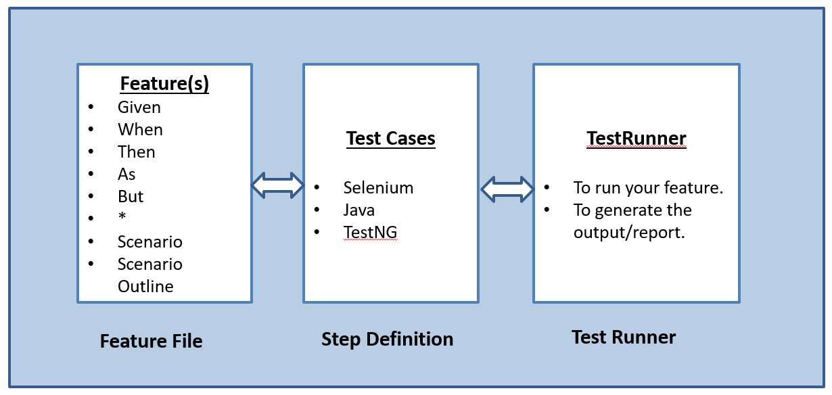

**what language is used by Cucumber?**

Ans: Gherkin is the language that is used by the Cucumber tool. It is a simple English representation of the application behaviour. Gherkin language uses several keywords to describe the behaviour of application such as Feature, Scenario, Scenario Outline, Given, When, Then etc.

**What is meant by a feature file?**

Ans: A feature file must provide a high-level description of an Application Under Test (AUT). The first line of the feature file must start with the keyword ‘Feature’ following the description of the application under test.

A feature file may include multiple scenarios within the same file. A feature file has the extension .feature.

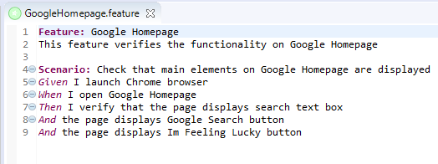

**What are the various Gherkin keywords that are used in Cucumber for writing a scenario?**

Ans: Mentioned below are the keywords that are used for writing a scenario:

* Given
* When
* Then
* And

**What is the purpose of Scenario Outline in Cucumber?**

Ans: Scenario outline is a way of parameterization of scenarios. This is ideally used when the same scenario needs to be executed for multiple sets of data, however, the test steps remain the same. Scenario Outline must be followed by the keyword ‘Examples’, which specify the set of values for each parameter. 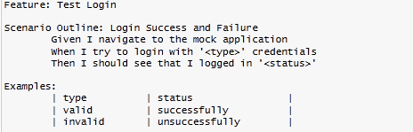

**What programming language is used by Cucumber?**

Ans: Cucumber tool provides support for multiple programming languages such as Java, .Net, Ruby etc. It can also be integrated with multiple tools such as Selenium, Capybara etc.

**What is the purpose of Step Definition file in Cucumber?**

Ans: A step definition file in Cucumber is used to segregate the feature files from the underlying code. Each step of the feature file can be mapped to a corresponding method on the Step Definition file. While feature files are written in an easily understandable language such as Gherkin, Step Definition files are written in programming languages such as Java, .Net, Ruby etc. 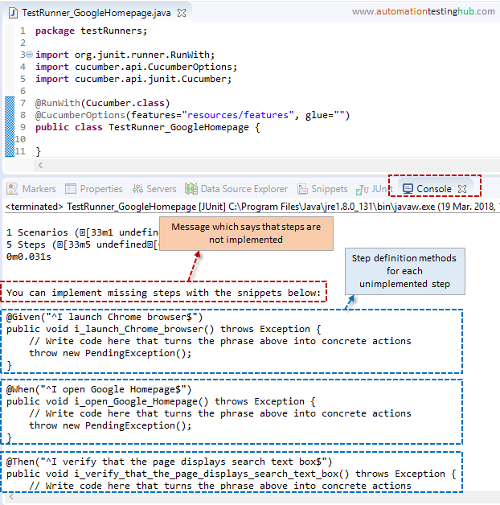

**What are the major advantages of Cucumber framework?**

Ans: Given below are the advantages of Cucumber Gherkin framework that make Cucumber an ideal choice for rapidly evolving agile methodology in today’s corporate world.

* Cucumber is an open source framework.
* Plain Text representation makes it easier for non-technical users to understand the scenarios.
* It remove the communication gap between various project stakeholders such as Business Analysts, Developers, and Quality Assurance personnel.
* Automation test cases developed using the Cucumber tool are easier to maintain and understand as well.
* Easy to integrate with other tools such as Selenium.

**What is the limit for the maximum number of scenarios that can be included in the feature file?**

Ans: A feature file can contain a maximum of 10 scenarios, but the number can vary from project to project and from one organization to another. But it is generally advisable to limit the number of scenarios included in the feature file.

**What is the use of Background keyword in Cucumber?**

Ans: Background keyword is used to group multiple given statements into a single group. This is generally used when the same set of given statements are repeated in each scenario of the feature file. 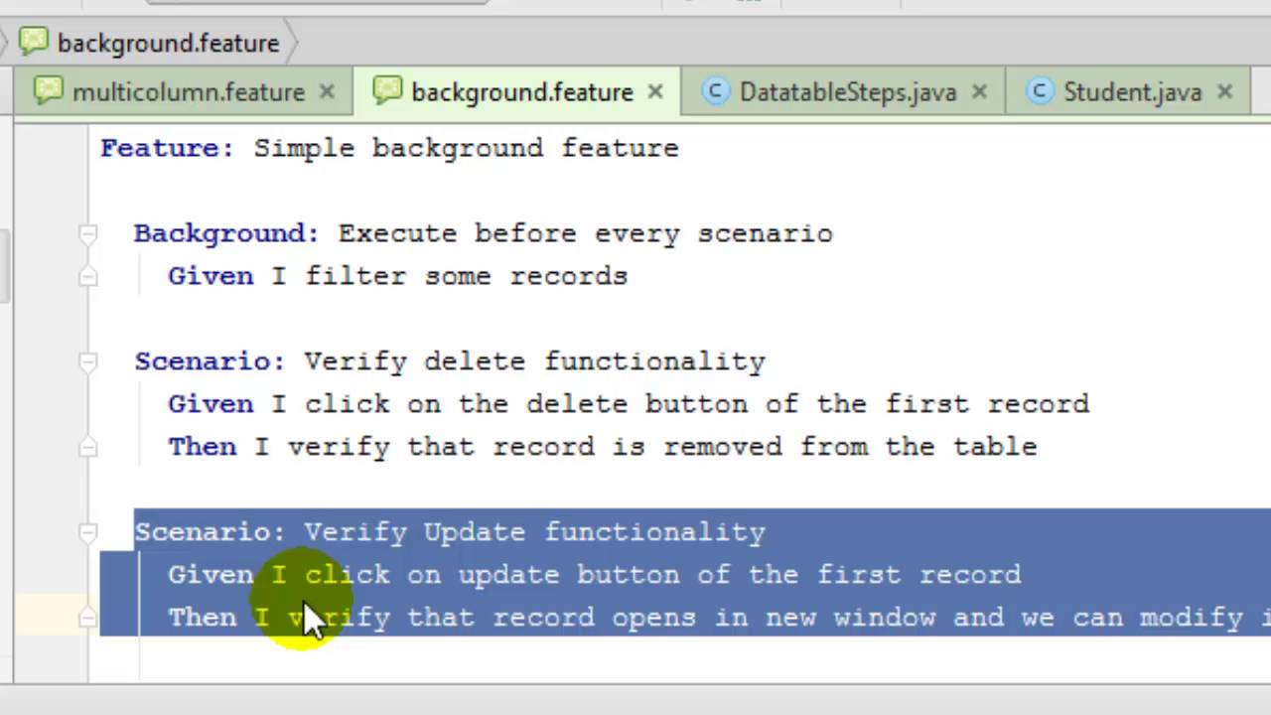

**What symbol is used for parameterization in Cucumber?**

Ans: Pipe symbol (|) is used to specify one or more parameter values in a feature file.

**What is the purpose of Examples keyword in Cucumber?**

Ans: Examples keyword is used to specify values for each parameter used in the scenario. Scenario Outline keyword must always be followed by the keyword Examples. 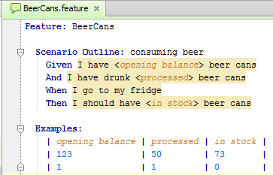

**What is the file extension for a feature file?**

Ans: File Extension for a feature file is .feature. A feature file is ideally written in a notepad file and is saved with the extension feature.

Q #17) Provide an example of step definition file in Cucumber.

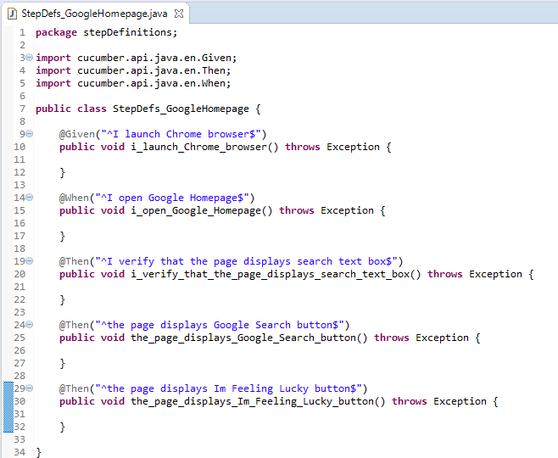

**What is the purpose of Cucumber Options tag?**

Ans: Cucumber Options tag is used to provide a link between the feature files and step definition files. Each step of the feature file is mapped to a corresponding method on the step definition file.Below is the syntax of Cucumber Options tag:

@CucumberOptions(features="Features",glue={"StepDefinition"})

**How can Cucumber be integrated with Selenium WebDriver?**

Ans: Cucumber can be integrated with Selenium webdriver by downloading the necessary JAR files.

Given below are the list of JAR files that are to be downloaded for using Cucumber with Selenium web driver:

cucumber-core-1.2.2.jar

cucumber-java-1.2.2.jar

cucumber-junit-1.2.2.jar

cucumber-jvm-deps-1.0.3.jar

cucumber-reporting-0.1.0.jar

gherkin-2.12.2.jar

**Explain the purpose of keywords that are used for writing a scenario in Cucumber.**

Ans: “Given” keyword is used to specify a precondition for the scenario. “When” a keyword is used to specify an operation to be performed. “Then” keyword is used to specify the expected result of a performed action. “And” keyword is used to join one or more statements together into a single statement.

**What is the name of the plugin that is used to integrate Eclipse with Cucumber?**

Ans: Cucumber Natural Plugin is the plugin that is used to integrate Eclipse with Cucumber.

**What is the meaning of TestRunner class in Cucumber?**

Ans: TestRunner class is used to provide the link between feature file and step definition file. Below is the sample representation of how TestRunner class will look like. A TestRunner class is generally an empty class with no class definition.

**Provide an example of TestRunner class in Cucumber.**

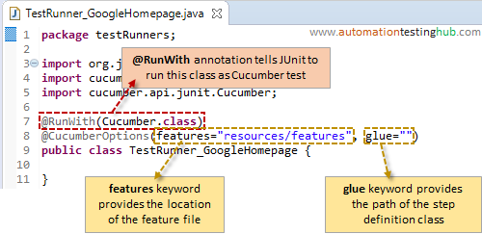

**What is the starting point of execution for feature files?**

Ans: When integrated with Selenium, the starting point of execution must be from TestRunner class.

**Should any code be written within TestRunner class?**

Ans: No code should be written under the TestRunner class. It should include the tags @RunWith and @CucumberOptions.

**What is the maximum number of steps that are to be written within a scenario?**

Ans: The maximum number of steps to be written in a scenario is 3-4 steps.

